**Lab Session 05**

**OBJECT**

***Exploring features of Microsoft Word***

**WORD PROCESSING CONCEPTS**

Microsoft Word is a word processing software package. You can use it to type letters, reports, and other documents. This lesson will introduce you to the Word window. You use this window to interact with Word.

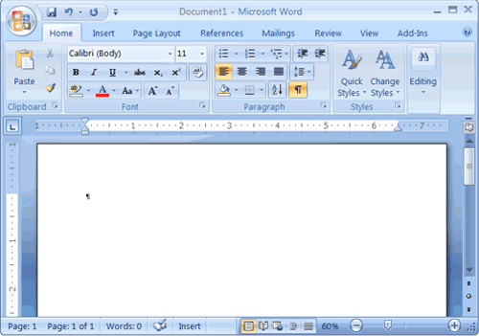

### ***Create Sample Data and Select Text***

**If you type =rand() in your Word document** and then press Enter, Word creates three paragraphs. You can use these paragraphs to practice what you learn. Throughout these lessons, you will be asked to select text. The following exercise teaches you how to create data and how to select data. You can select by using the arrow keys or by clicking and dragging. When using the arrow keys, use the up arrow to move up, the down arrow to move down, the left arrow to move left, and the right arrow to move right. When using the mouse, press the left mouse button and then drag in the direction you want to move.

### ***The Quick Access Toolbar***

Next to the Microsoft Office button is the Quick Access toolbar. The Quick Access toolbar provides you with access to commands you frequently use. By default Save, Undo, and Redo appear on the Quick Access toolbar. You can use Save to save your file, Undo to rollback an action you have taken, and Redo to reapply an action you have rolled back.

***The Title Bar***



Next to the Quick Access toolbar is the Title bar. The Title bar displays the title of the document on which you are currently working. Word names the first new document you open Document1. As you open additional new documents, Word names them sequentially. When you save your document, you assign the document a new name.



***The Ribbon*** You use commands to tell Microsoft Word what to do. In Microsoft Word 2007, you use the Ribbon to issue commands. The Ribbon is located near the top of the screen, below the Quick Access toolbar. At the top of the Ribbon are several tabs; clicking a tab displays several related command groups. Within each group are related command buttons. You click buttons to issue commands or to access menus and dialog boxes. You may also find a dialog box launcher in the bottom-right corner of a group. Clicking the dialog box launcher gives you access to additional commands via a dialog box.

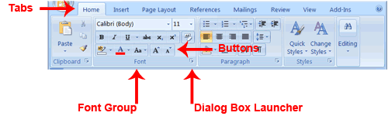

### ***The Ruler***

The ruler is found below the Ribbon.



You can use the ruler to change the format of your document quickly. If your ruler is not visible, follow the steps listed here:

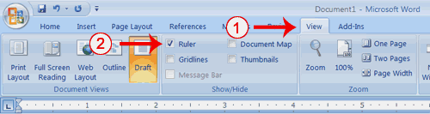

1. Click the View tab to choose it.
2. Click the check box next to Ruler in the Show/Hide group. The ruler appears below the Ribbon.

**The Status Bar** The Status bar appears at the very bottom of your window and provides such information as the current page and the number of words in your document. You can change what displays on the Status bar by right-clicking on the Status bar and selecting the options you want from the Customize Status Bar menu. You click a menu item to select it. You click it again to deselect it. A check mark next to an item means it is selected.

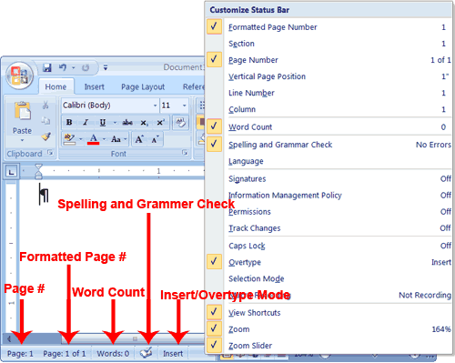

**Understanding Document Views**

Draft View

Draft view is the most frequently used view. You use Draft view to quickly edit your document.

Web Layout

Web Layout view enables you to see your document as it would appear in a browser such as Internet Explorer.

Print Layout

The Print Layout view shows the document as it will look when it is printed.

Reading Layout

Reading Layout view formats your screen to make reading your document more comfortable.

Outline View

Outline view displays the document in outline form. You can display headings without the text. If you move a heading, the accompanying text moves with it.

You should use Draft view for these lessons. Before moving ahead, make sure you are in Draft view:

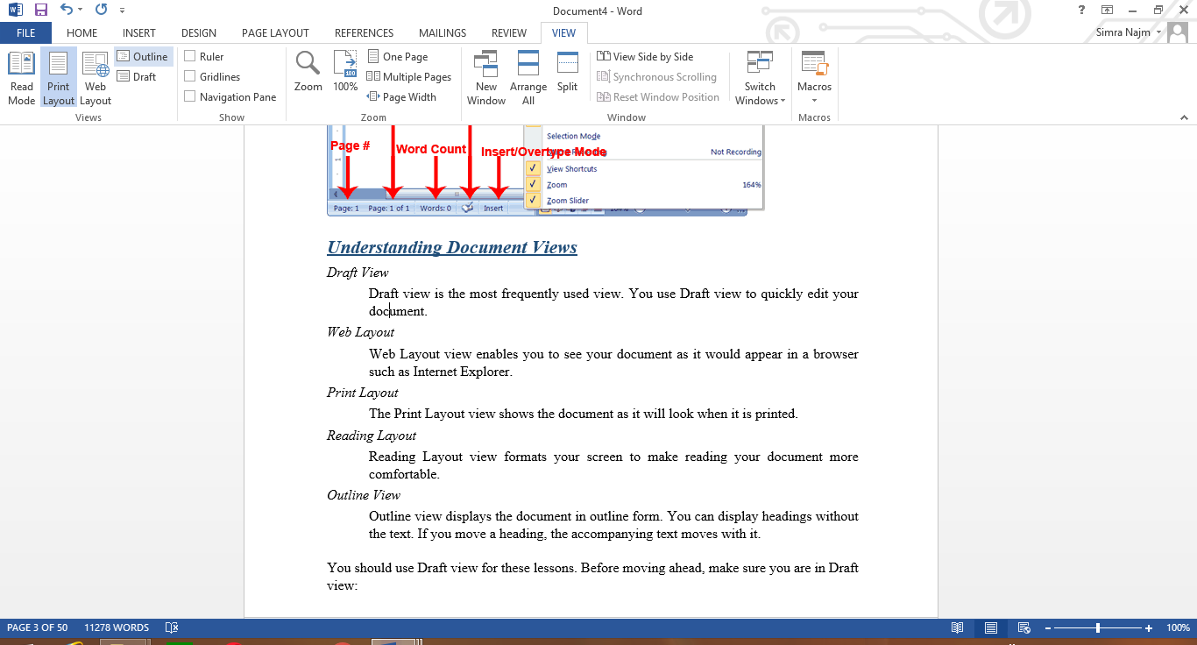

1. Click the View tab.
2. Click Draft in the Document Views group. When the Draft option is selected it appears in a contrasting color.

### ***Understanding Nonprinting Characters***

Certain characters, called nonprinting characters, do not print and will not appear in your printed document but do affect your document layout. You can elect to see these characters on the screen as you type or you can elect to have them remain invisible. For these lessons, opt to see them onscreen. This table describes most of them:

|  |  |
| --- | --- |
| **Character** | **Denotes** |
|  | A tab |
| . | A space |
| ¶ | The end of a paragraph |
|  | Hidden text |

To view nonprinting characters:

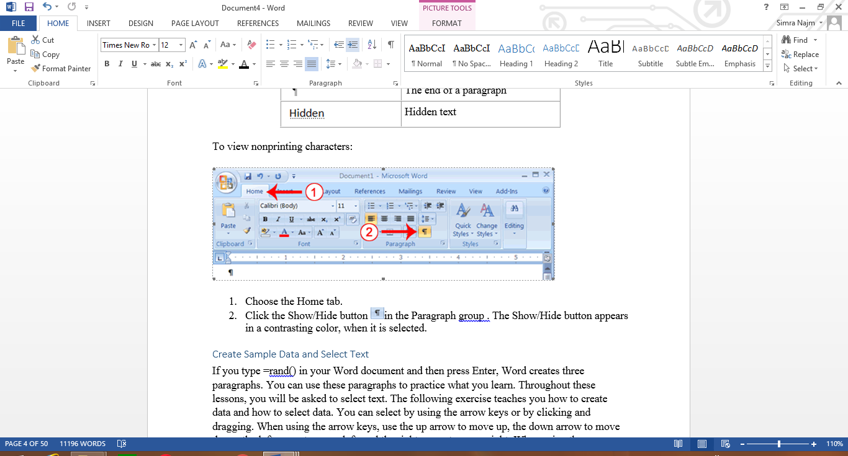

1. Choose the Home tab.
2. Click the Show/Hide button in the Paragraph group . The Show/Hide button appears in a contrasting color, when it is selected

***Working with Shapes***

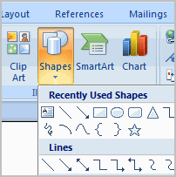

You can add a **variety of shapes** to your document, including arrows, callouts, squares, stars, and flow chart symbols. Want to offset your name and address from the rest of your resume? Use a line. Need to show the progress of a document through your office? Use a flow chart. While you may not need shapes in every document you create, they can add **visual appeal and clarity** to many documents.   
  
In this lesson, you will learn how to insert a shape and format it by changing its fill color, outline color, shape style, and shadow effects. Additionally, you will learn to apply 3D effects to shapes that have this option.

#### To insert a shape:

* Select the **Insert** tab.
* Click the **Shape** command.
* Left-click a shape from the menu. Your cursor is now a cross shape.
* Left-click your mouse and while holding it down, drag your mouse until the shape is the desired size.
* Release the mouse button.

**To change shape style**: Select the shape. A new **Format tab** appears with Drawing Tools.

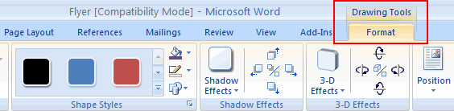

* Click the **More drop-down arrow** in the Shapes Style group to display more style options.

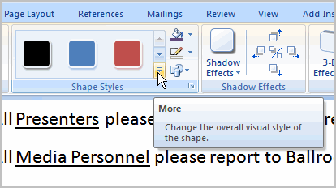

* Move your cursor over the styles, and Live Preview will preview the style in your document.
* Left-click a style to select it.

#### To change the shape fill color:

* Select the shape. A new **Format tab** appears with Drawing Tools.
* Click the **Shape Fill** command to display a drop-down list.

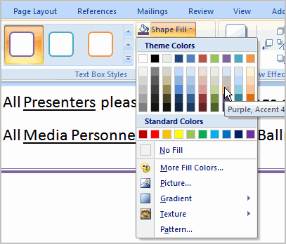

* Select a color from the list, choose No Fill, or choose one of the other options.

#### To change the shape outline:

* Select the shape. A new **Format tab** appears with Drawing Tools.
* Click the **Shape Outline** command to display a drop-down list.
* Select a color from the list, choose No Outline, or choose one of the other options.

#### To change to a different shape:

* Select the shape. A new **Format tab** appears with Drawing Tools.
* Click the **Change Shape** command to display a drop-down list.

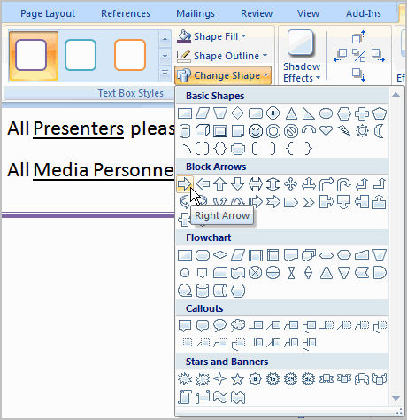

* Select a shape from the list.

#### To change shadow effects:

* Select the **Format** tab.
* Left-click the **Shadow Effects** command.
* Move your mouse over the menu options. Live Preview displays how it will appear in your document.

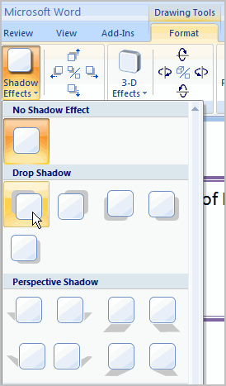

* Click an option to select the shadow effect.

Select **Shadow Color** from the menu, and choose a color from the palette to change the color of the shadow on your shape.

#### To change 3D effects:

You cannot add a 3D effect to **all shapes**.

* Select the **Format** tab.
* Left-click the **3-D Effects** command.
* Move your mouse over the menu options. Live Preview displays how it will appear in your document.

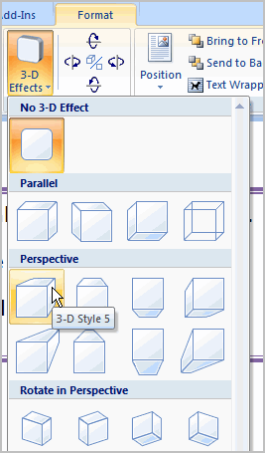

* Click an option to select the 3D effect.

After you have chosen a **3D effect**, you can change other elements of your shape, including the **color, depth, direction, lighting, and surface** of the 3D effect on your shape. This can dramatically change the way the shape looks. You can access these options by clicking the 3-D Effects command

### **Bold, Italicize, and Underline**

When creating a document, you may need to emphasize particular words or phrases by bolding, underlining, or italicizing. Also, certain grammatical constructs require that you bold, underline, or italicize.  You can  bold, underline, and italicize when using Word. You also can combine these features—in other words, you can bold, underline, and italicize a single piece of text.

When you need to perform a task in Microsoft Word, you can usually choose from several methods. The exercises that follow show you how to bold, underline, or italicize using four different methods: using the launcher, the Ribbon, the Mini-toolbar/context menu, and the keyboard.

#### Bold with the Dialog Box Launcher

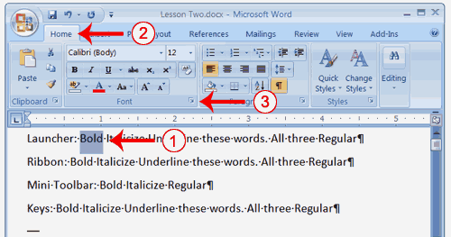

1. On the line that begins with Launcher, select the word "Bold."  You can place the cursor before the letter "B" in "Bold." Press the Shift key; then press the right arrow key until the entire word is highlighted.
2. Choose the Home tab.
3. Click the dialog box launcher in the Font group. The Font dialog box appears
4. Click Bold in the Font Style box.
5. Note: You can see the effect of your action in the Preview window. To remove the bold, click Regular.
6. Click OK to close the dialog box.
7. Click anywhere in the text area to remove the highlighting. You have bolded the word bold..

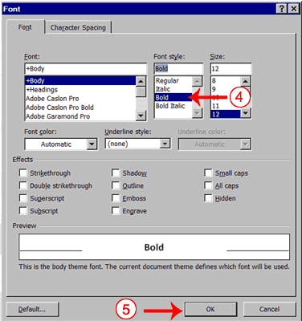

#### Alternate Method—Bold with the Ribbon

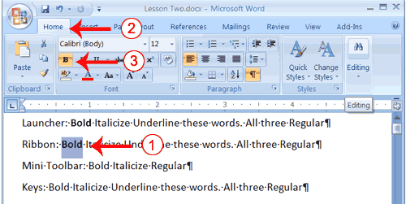

1. On the line that begins with "Ribbon," select the word "Bold."  You can place the cursor before the letter "B" in "Bold." Press the Shift key; then press the right arrow key until the entire word is highlighted.
2. Choose the Home tab.
3. Click the Bold button in the Font group. You have bolded the word bold.  
   **Note:** To remove the bold, you can select the text and then click the Bold button again.



1. Click anywhere in the text area to remove the highlighting.

#### Alternate Method - Bold with the Mini Toolbar

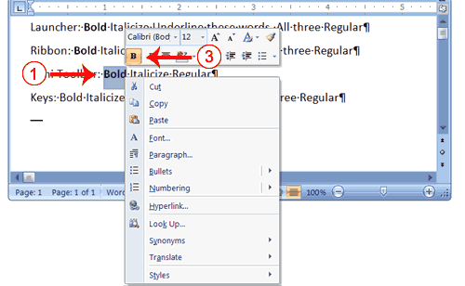

1. On the line that begins with "Mini Toolbar," select the word "Bold."  You can place the cursor before the letter "B" in "Bold."Press the Shift key; then press the right arrow key until the entire word is highlighted.
2. Right-click. The Mini toolbar appears.
3. Click the Bold button . You have bolded the word bold.



#### Alternate Method—Bold with Keys

1. On the line that begins with "Keys," select the word "Bold."  You can place the cursor before the letter "B" in "Bold." Press the Shift key; then press the right arrow key until the entire word is highlighted.
2. Press Ctrl+b (hold down the Ctrl key while pressing b).   
   **Note:** To remove the Bold, press Ctrl+b again. You can also remove formatting by pressing Ctrl+spacebar.
3. Click anywhere in the text area to remove the highlighting.

#### Italicize with the Dialog Box Launcher

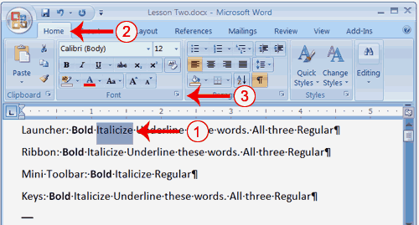

1. On the line that begins with Launcher, select the word "Italicize."  You can place the cursor before the letter "I" in "Italicize." Press the Shift key; then press the right arrow key until the entire word is highlighted.
2. Choose the Home tab.
3. Click the dialog box launcher in the Font group. The Font dialog box appears.
4. Click Italicin the Font Style box.  
   **Note:** You can see the effect of your selection in the Preview window. To remove the italics, click Regular in the Font Style box.
5. Click OK to close the Font dialog box.
6. Click anywhere in the text area to remove the highlighting. You have italicized the word Italicize.

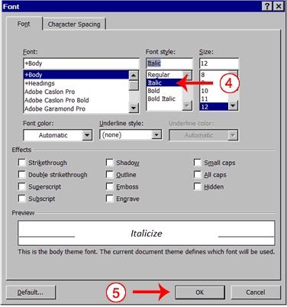

#### Alternate Method—Italicize with the Ribbon

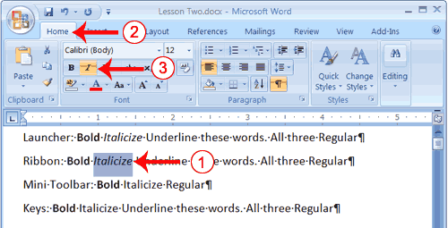

1. On the line that begins with "Ribbon," select the word "Italicize." You can place the cursor before the letter "I" in "Italicize." Press the Shift key; then press the right arrow key until the entire word is highlighted.
2. Choose the Home tab.
3. Click the Italic button on the Ribbon. You have italicized the word Italicize.  
   **Note:** To remove the italics, select the text and click the Italicize button again.



1. Click anywhere in the text area to remove the highlighting.

#### Alternate Method—Italicize with the Mini Toolbar

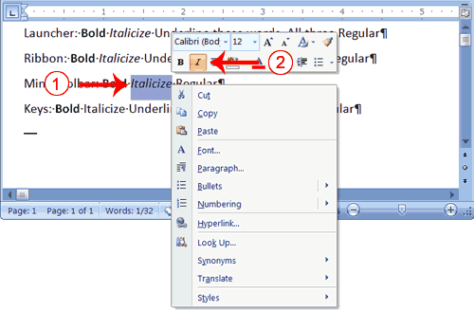

1. On the line that begins with "Mini Toolbar," select the word "Italicize." You can place the cursor before the letter "I" in "Italicize." Press the Shift key; then press the right arrow key until the entire word is highlighted.
2. Right-click. The Mini toolbar appears.
3. Click the Italic button . You have italicized the word Italicize.



#### Alternate Method—Italicize with Keys

1. On the line that begins with "Keys," select the word "Italicize." You can place the cursor before the letter "I" in "Italicize." Press the Shift key; then press the right arrow key until the entire word is highlighted.
2. Press Ctrl+i (hold down the Ctrl key while pressing i).   
   **Note:** To remove italics, press Ctrl+i again. You can also remove formatting by pressing Ctrl+spacebar.
3. Click anywhere in the text area to remove the highlighting.You have italicized the word Italicize.

#### Underline with the Dialog Box Launcher

You can underline when using Word. Word provides you with many types of underlines from which to choose.The following are some of the underlines that are available if you use the dialog box launcher:

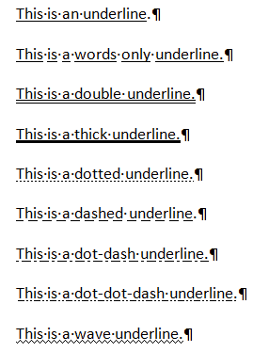

The following illustrates underlining with the dialog box launcher:

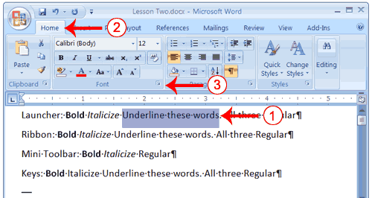

1. On the line that begins with "Launcher," select the words "Underline these words."
2. Choose the Home tab.
3. Click the dialog box launcher in the Font group. The Font dialog box appears.

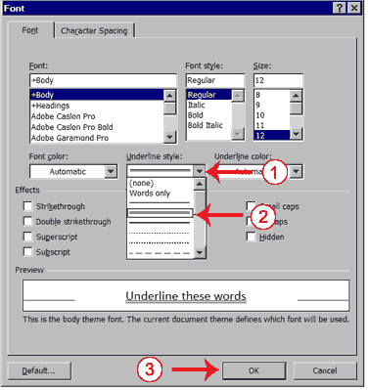

1. In the Underline Style box, click the down arrow to open the pull-down menu.
2. Click the type of underline you wish to use.   
   **Note:** To remove an underline, you select None from the pull-down menu.
3. Click OK to close the dialog box. The underline you selected appears under the words.
4. Click anywhere in the text area to remove the highlighting.

#### Alternate Method—Underline with the Ribbon

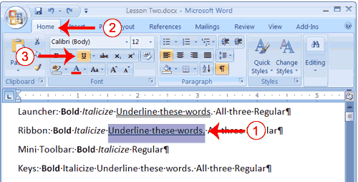

1. On the line that begins with "Ribbon," select the words "Underline these words."
2. Choose the Home tab.
3. Click the Underline button in the Font group . Alternatively, you can press the down arrow next to the underline button and click to choose the type of underline you want.  
   **Note:** To remove the underlining, click the Underline button again.



1. Click anywhere in the text area to remove the highlighting.

#### Alternate Method—Underline with Keys

1. On the line that begins with "Keys," select the words "Underline these words."
2. Press Ctrl+u (hold down the Ctrl key while pressing u).   
   **Note:** To remove the underlining, press Ctrl+u again.
3. Click anywhere in the text area to remove the highlighting.

#### All Three with the Dialog Box Launcher

1. On the line that begins with "Launcher," select the words "All three."
2. Choose the Home tab.
3. Click the dialog box launcher in the Font group. The Font dialog box appears.
4. In the Font Style box, click Bold Italic**.**  
   **Note:** You can see the effect of your selection in the preview window. To turn off the Bold Italic, click Regular.
5. In the Underline box, click to open the pull-down menu. Click the type of underline you want to use.  
   **Note:** To remove an underline, select None from the pull-down menu.
6. Click OK to close the dialog box.
7. Click anywhere in the text area to remove the highlighting.

#### Alternate Method—All Three with the Ribbon

1. On the line that begins with "Ribbon," select the words "All three."
2. Choose the Home tab.
3. Click the Bold button in the Font group.



1. Click the Italic button in the Font group.



1. Click the Underline button in the Font group.



1. Click anywhere in the text area to remove the highlighting.

#### Alternate Method—All Three with Keys

1. On the line that begins with "Keys," select the words "All three."
2. Press Ctrl+b (bold).
3. Press Ctrl+i (italicize).
4. Press Ctrl+u (underline).   
   **Note:** You can remove formatting by highlighting the text and pressing Ctrl+spacebar.
5. Click anywhere in the text area to remove the highlighting.

### Save a File and Close Word

You must save your documents if you wish to recall them later. You can use the Save option on the Microsoft Office menu, to save a document. You can also save a document by typing Ctrl+s. The first time you save a document, the Save As dialog box appears.  Use the Save As dialog box to locate the folder in which you want to save your document and to give your document a name. After you have saved your document at least once, you can save any changes you make to your document simply by clicking the Save after you click the Microsoft Office button.

**Use Spell Check**

Word checks your spelling and grammar as you type. Spelling errors display with a red wavy line under the word. Grammar errors display with a green wavy line under the error. In Word 2007, you can use the Review tab's Spelling & Grammar button to initiate a spell and grammar check of your document.

#### Use Spell Check

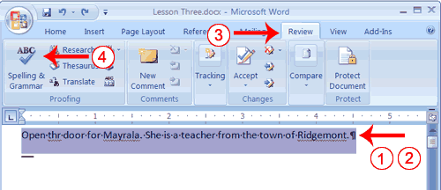

1. Type the following exactly as shown. Include all errors.   
   **Open the door for Mayrala. She is a teacher from the town of Ridgemont.**
2. Select: "Open thr door for Mayrala. She is a teacher from the town of Ridgemont."
3. Choose the Review tab.
4. Click the Spelling & Grammar button. The Spelling and Grammar dialog box appears.

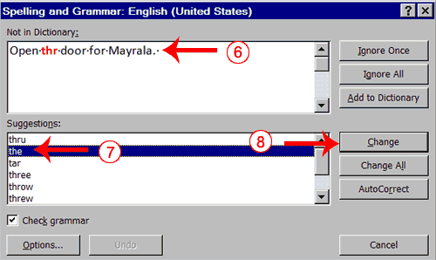

1. "The" is misspelled, so it is highlighted on the screen and noted in the Not in Dictionary box. Word suggests correct spellings. These suggestions are found in the Suggestions box.
2. Click "the" in the Suggestions box.
3. Click Change.   
   **Note:** If the word is misspelled in several places, click Change All to correct all misspellings.
4. The name "Mayrala" is not in the dictionary, but it is correct. Click Ignore Once to leave "Mayrala" in the document with its current spelling.  
   **Note:** If a word appears in several places in the document, click Ignore All so you are not prompted to correct the spelling for each occurrence.
5. "Ridgemont" is not found in the dictionary. If you frequently use a word not found in the dictionary, you might want to add that word to the dictionary by clicking the Add to Dictionary button. Word will then recognize the word the next time it appears. Click Add to Dictionary.
6. The following should appear on your screen: "Word finished checking the selection. Do you want to continue checking the remainder of the document?"
7. Click No. If you wanted Word to spell-check the entire document, you would have clicked yes.

**Note:** You can also press F7 to initiate a spelling and grammar check. If you don't have anything selected, Word checks the entire document.

### Find and Replace

If you need to find a particular word or phrase in your document, you can use the Find command. This command is especially useful when you are working with large files. If you want to search the entire document, simply execute the Find command. If you want to limit your search to a selected area, select that area and then execute the Find command.

After you find the word or phrase you are searching for, you can replace it with new text by executing the Replace command.

### **Add Sample Text**

This lesson uses sample text provided by Microsoft for training and demonstration purposes. You can type the text; however, there is a quicker way. You can use the rand function.

Functions are used to obtain information. You tell the function what you want and the function returns that information to you. By default, in Word, when you type the rand function, Word returns three paragraphs. When working with functions, you use arguments to be specific about what you want the function to return. There are two arguments you can use with the rand function. The first one tells Word how many paragraphs you want, and the second one tells Word how many sentences you want in a paragraph. You place arguments between the parentheses and you separate them with a comma. For example, if you type =rand() and then press Enter, word returns three paragraphs. To tell Word you want two paragraphs with three sentences in each paragraph, you type =rand(2,3).

### Apply a Style

You can see of all the styles available to you in the style set by clicking the launcher in the Styles group and opening the Styles pane. You can leave the Styles pane open and available for use by docking it. To dock the Styles pane, click the top of the pane and drag it to the left or right edge of the Word window.

You do not need to select an entire paragraph to apply a style. If the cursor is anywhere in the paragraph, when you click on the style, Word formats the entire paragraph.

#### Apply the Title Style

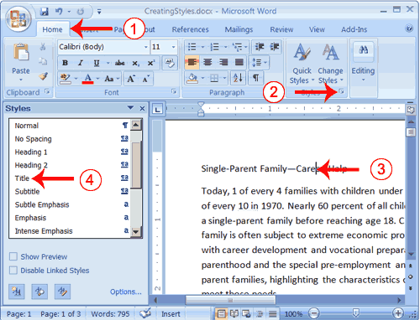

1. Choose the Home tab.
2. Click the launcher in the Styles Group. The Styles pane appears. You can drag it to the side of the Word window to dock it. To close the Styles pane, click the Close button in the upper right corner of the pane .



1. Click anywhere in the paragraph "Single-Parent Family—Career Help."
2. Click Title in the Styles pane. Word 2007 applies the Title style to the paragraph.

Headings and subheadings mark major topics within your document. With Word 2007, you can easily format the headings and subheadings in your document.

# *Apply Headings*

1. Click anywhere in the paragraph "The Nature of Single Parenthood."
2. In the Style box, click Heading 1. Word reformats the paragraph.
3. Repeat steps 1 and 2 in the following paragraphs:

* Types of Single Parents
* Career Development Needs of Single Parents
* Career Development Programs

#### Apply Subheadings

1. Click anywhere in the paragraph "Displaced Homemakers"
2. In the Style box, click Heading 2. Word reformats the paragraph.
3. Repeat steps 1 and 2 for the following paragraphs:

* Displaced Homemakers
* Adolescent Mothers
* Single Fathers
* High School Dropout Prevention
* Established Education Sites

#### Alternate Method -- Apply Styles with the Ribbon

You can also choose styles by selecting the option you want from the Styles group on the Ribbon. First you must place your cursor in the paragraph to which you want to apply the style. Then you click the More button in the Styles group to see all of the styles in the currently selected set. As you roll your cursor over each of the styles listed, Word 2007 provides you with a live preview of how the style will appear when applied.

1. Select the paragraphs "Emotional Support" through "Parenthood Education" (they are probably on page two).
2. Click the More button in the Styles group.
3. Locate and click the List Paragraph style. Word applies the List Paragraph style to the paragraphs you selected.

### Change Style Sets

Once you have applied styles, changing to another style set is easy. You simply open the Style Set gallery. As you move your cursor down the menu, Word 2007 provides you with a live preview of the effect of applying the style set. To choose a style set, you click it.

## Adding Bullets and Numbers, Undoing and Redoing, Setting Page Layouts and Printing Documents

If you have lists of data, you may want to bullet or number them. When using Microsoft Word, bulleting and numbering are easy. The first part of this lesson teaches you to bullet and number.

After you have completed your document, you may want to share it with others. One way to share your document is to print and distribute it. However, before you print you may want to add page numbers and tell Word such things as the page orientation, the paper size, and the margin setting you want to use. In this lesson you will learn how to layout and how to print your documents.

### Add Bullets and Numbers

In Microsoft Word, you can easily create bulleted or numbered lists of items. Several bulleting and numbering styles are available, as shown in the examples. You can select the one you wish to use.

**EXAMPLES:** Numbering

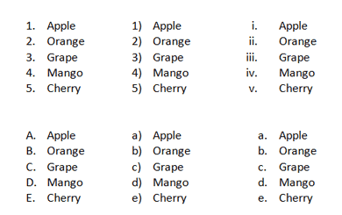

**EXAMPLES:** Bulleting

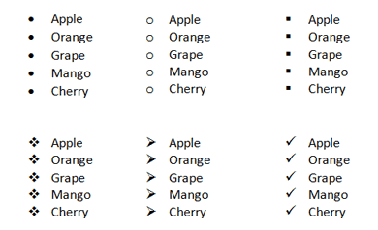

#### Bullets

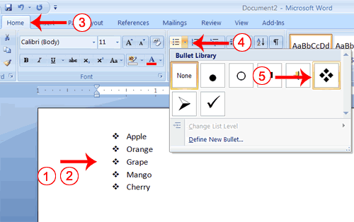

1. Type the following list as shown:  
   **Apple**   
   **Orange**   
   **Grape**   
   **Mango**   
   **Cherry**
2. Select the words you just typed.
3. Choose the Home tab.
4. In the Paragraph group, click the down arrow next to the Bullets button . The Bullet Library appears.



1. Click to select the type of bullet you want to use. Word adds bullets to your list.  
   **Note:** As you move your cursor over the various bullet styles, Word displays the bullet style onscreen.

To remove the bulleting:

1. Select the list again.
2. Choose the Home tab.
3. In the Paragraph group, click the down arrow next to the Bullets icon. The Bullet dialog box appears.
4. Click None. Word removes the bullets from your list.

#### Numbers

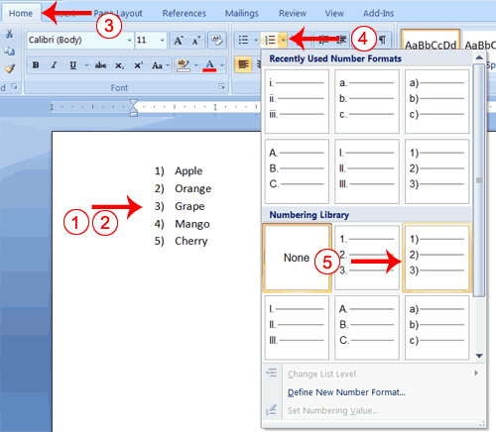

1. Type the following list as shown:  
   **Apple**   
   **Orange**   
   **Grape**   
   **Mango**   
   **Cherry**
2. Select the words you just typed.
3. Choose the Home tab.
4. In the Paragraph group, click the down arrow next to the Numbering button . The Numbering Library appears.



1. Click to select the type of numbering you want to use. Word numbers your list.  
   **Note:** As you move your cursor over the various number styles, Word displays the number style onscreen.

To remove the numbering:

1. Select the list again.
2. Choose the Home tab.
3. In the Paragraph group, click the down arrow next yo the Numbering icon. The Number dialog box appears.
4. Click None. Word removes the numbering from your list.

### 

### Undo and Redo

You can quickly reverse most commands you execute by using Undo. If you then change your mind again, and want to reapply a command, you can use Redo.

#### Undo and Redo

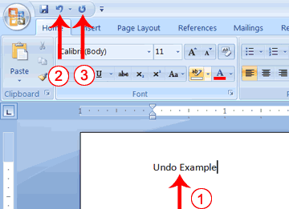

1. Type **Undo example**.
2. Click the Undo button on the Quick Access menu. The typing disappears.
3. Click the Redo button on the Quick Access menu. The typing reappears.
4. Select "Undo example."
5. Press Ctrl+b to bold. Word bolds the text.
6. Press Ctrl+i. Word italicizes the text.
7. Press Ctrl+u Word underlines the text.
8. Click the down arrow next to the Undo icon. You will see the actions you performed listed. To undo the underline, click Underline; to undo the underline and italic, click Underline Italic; to undo the underline, italic, and bold click Bold etc.
9. To redo, click the Redo icon several times.

#### Alternate Method -- Undo & Redo by Using Keys

1. Type **Undo example**.
2. Press Ctrl+z. The typing disappears.
3. Press Ctrl+y. The typing reappears.
4. Select "Undo example."
5. Press Ctrl+u to underline.
6. Press Ctrl+z. The underline is removed.
7. Press Ctrl+y. The underline reappears.

### Set the Orientation

Before you print your document, you may want to change the orientation of your pages. There are two orientations you can use: portrait and landscape. Paper, such as paper sized 8 1/2 by 11, is longer on one edge than it is on the other. If you print in Portrait, the shortest edge of the paper becomes the top of the page. Portrait is the default option. If you print Landscape, the longest edge of the paper becomes the top of the page.

|  |
| --- |
| Portrait |

|  |
| --- |
| Landscape |

The exercises that follow use a file named SamplePrint.docx. [Right click here to download the file.](http://www.baycongroup.com/word2007/SamplePrint.zip) Click Save Target As from the menu that appears, and save the linked file to a directory on your computer. The file will download as a zip file. A zip file is a file that is compressed. Compressed files are smaller and easier to download. To open the file:

1. Open the folder you downloaded the file to.
2. Right-click on the file name.
3. Click Extract All on the menu that appears. The Extract Compressed (Zipped) Folders dialog box appears.
4. Enter the folder you want to put the file in or except to suggested location.
5. Click Extract. Windows Explorer extracts the file.
6. You can use Microsoft Word to open the file.

#### Set the Orientation

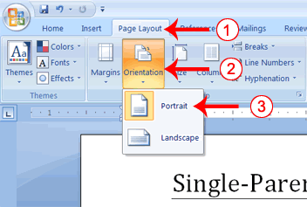

1. Choose the Page Layout tab.
2. Click Orientation in the Page Setup group. A menu appears.
3. Click Portrait. Word sets your page orientation to Portrait.

### Set the Page Size

Paper comes in a variety of sizes. Most business correspondence uses 8 1/2 by 11 paper which is the default page size in Word. If you are not using 8 1/2 by 11 paper, you can use the Size option in the Page Setup group of the Page Layout tab to change the Size setting.

#### Set the Page Size

1. Choose the Page Layout tab.
2. Click Size in the Page Setup group. A menu appears.
3. Click Letter 8.5 x 11in. Word sets your page size.

### Set the Margins

Margins define the amount of white space that appears at the top, bottom, left, and right edges of your document. The Margin option in the Page Setup group of the Page Layout tab provides several standard margin sizes from which you can choose. **Set the Margins**

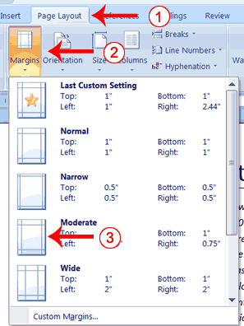

1. Choose the Page Layout tab.
2. Click Margins in the Page Setup group. A menu appears.
3. Click Moderate. Word sets your margins to the Moderate settings.

***Add Page Numbers*** Page numbers help you keep your document organized and enable readers to find information quickly. You can add page numbers to the top, bottom, or margins of your pages, and you can choose where the numbers appear. For example, numbers can appear at the top of the page, on the left, right, or center of the page. Word also offers several number styles from which you can choose

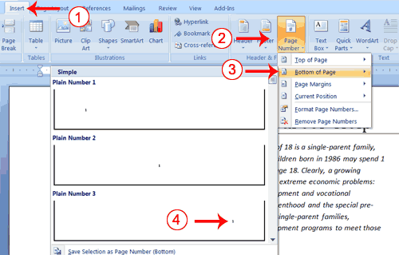

1. Choose the Insert tab.
2. Click the Page Number button in the Header & Footer group. A menu appears.
3. Click Bottom of Page.
4. Click the right-side option.

**Preview and Print Documents**

When you have your margins, tabs, and so on the way you want them, you are ready to print. In Word, You can preview your document before you print. In the Preview mode, you can review each page, view multiple pages at the same time, zoom in on a page, and access the Size, Orientation, and Margin options.

If you press the Zoom button while you are in Preview mode, the Zoom dialog box appears. In the Zoom dialog box you can set the sizes of the pages that display as well as the number of pages that display.

When you are ready to print, you use the Print dialog box. In the Print Range area, choose All to print every page of your document, choose Current Page to print the page you are currently on, or choose Pages to enter the specific pages you want to print. Type the pages you want to print in the Pages field. Separate individual pages with commas (1,3, 13); specify a range by using a dash (4-9).

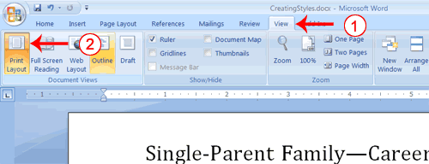

1. Choose the View tab.
2. Click Print Layout in the Document Views group. Your document changes to the Print Layout view

### **Insert Page Breaks:**

you can display your document in any of five views: Draft, Web Layout, Print Layout, Full Screen Reading, or Online Layout. In Print Layout view you see your document as it will appear when you print it. You can clearly see where each page ends and a new page begins.

As you review your document, you may find that you want to change the point at which a new page begins. You do this by inserting a page break. For example, if a page heading appears on one page and the first paragraph under the heading appears on the next page, you may want to inser a page break before the heading to keep the heading and the first paragraph together. Change to Print View

***Insert Page Breaks***

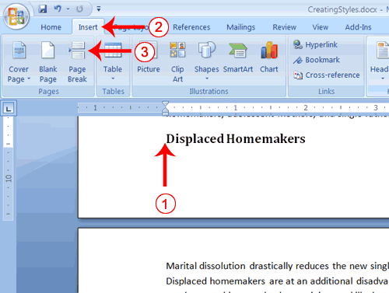

1. Place your cursor before the D in "Displaced Homemakers"
2. Choose the Insert tab.
3. Click Page Break. Word places a page break in your document.

To delete a page break, you select the page break and then press the Delete key.

Exercise 1

Create an adverisement as shown below with different colour theme.

